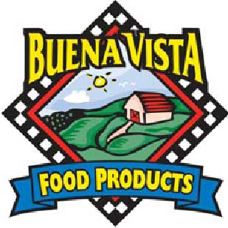

BV RF Checkerboard Cookie - 2.0 oz, SKU# 70360 (IW)
BV RF Checkerboard Cookie - 2.0 oz, SKU# 70350 (B)
BV RF Checkerboard Cookie Dough - 2.0 oz, SKU# 75330

Nutrition Facts | Total Fat 8 g 12% Total Carbohydrate 37 g 12%  Sat Fat 3 g 15% Fiber 1 g 4%  Trans fat 0 g Sugars 20 g  Cholesterol 0 mg 0% Protein 3 g  Sodium 170 mg 7%
Amt/Serving size; 2.0 oz
(57 grams)
Servings per container: 1
Calories 220
Calories from Fat 70
Vit A – 0% * Vit C – 0% * Calcium – 2% * Iron – 10%

Ingredients:
Flour (Enriched flour, (WHEAT FLOUR, Malted Barley Flour, Niacin, Iron, Thiamin Mononitrate, Riboflavin, Folic Acid), Sugar, water, Shortening (Refined, Bleached and Deodorized Soybean Oil and Fully Hydrogenated Soybean Oil Blend with citric acid added as a preservative), White Cookie Drops (sugar, partially hydrogenated palm kernel oil, whey, nonfat milk, mono and diglyceride and soya lecithin emulsifiers, pure vanilla), Chocolate Chips (Sugar, Chocolate Liquor, Cocoa Butter, Soy Lecithin (an emulsifier), Vanilla, salt), COCOA (PROCESSED WITH ALKALI), Raisin Paste, CONTAINS LESS THAN 2% of: Egg REPLACER (enriched wheat flour (wheat flour, malted barley flour, Niacin, Iron, Thiamin Mononitrate, Riboflavin, Folic Acid), Defatted Soybean flour, Dextrose, Emulsifier (mono and diglycerides, ethoxylated mono and Diglycerides), sugar, dried egg yolks, soybean oil, soybean lecithin, guar gum), Food starch-modified, Bicarbonate of Soda, SALT, Natural vanilla flavor (Glycerin, alcohol, water, sugar, natural flavors (including vanilla bean extractives), propylene glycol)

CONTAINS: MILK, Egg, SOY, WHEAT

BREAD SERVINGS: (57 X 0.312)/14.75 = 1.2 Breads (Rounds down to 1 Bread)

Breads | Fruit/Vegetable | Protein
1.0 | Na | Na

I certify that the above information is true and correct.
6/1/2011 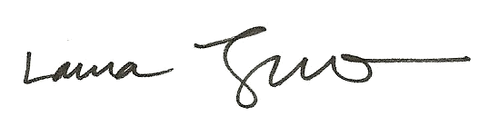
Date Laura Trujillo, RD, SNS

